Electronic Appendix D. Information in the literature cited below was used to develop a dated phylogenetic hypothesis expressing relationships among amphibian species included in the meta-analysis. The phylogeny was then used to construct the relationship matrix A in Eqn 1 of the paper. The anuran portion of the phylogeny came from Gomez-Mestre et al. (2012); the caudate portion is largely from Wiens (2007). Estimated divergence dates for the nodes labeled in the phylogeny are listed in the table below. The phylogeny follows traditional taxonomy, which is appropriate until the ongoing debate among systematists is resolved (Hillis, 2007; Pauly et al., 2009).

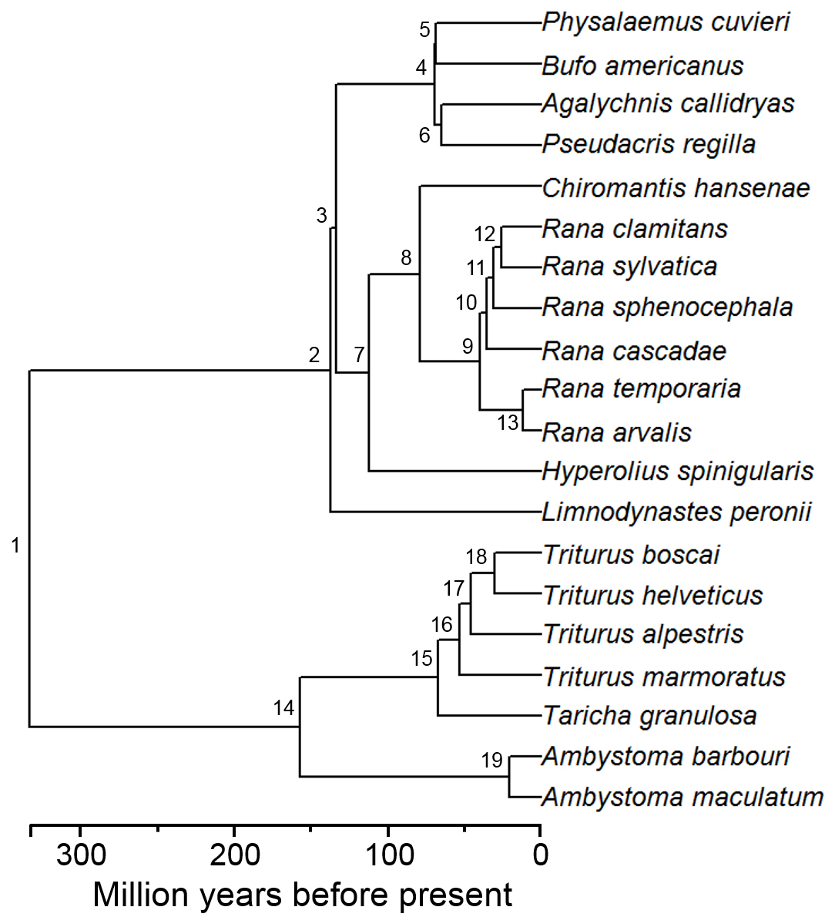

Node Age (Mya) Source

1 332.2 Wiens, 2011
2 136.9 Gomez-Mestre et al., 2012
3 133.8 Gomez-Mestre et al., 2012
4 69.3 Gomez-Mestre et al., 2012
5 68.5 Gomez-Mestre et al., 2012
6 65.2 Gomez-Mestre et al., 2012
7 111.9 Gomez-Mestre et al., 2012
8 79.3 Gomez-Mestre et al., 2012
9 39.6 Gomez-Mestre et al., 2012
10 35.4 Gomez-Mestre et al., 2012
11 31.2 Gomez-Mestre et al., 2012
12 25.6 Gomez-Mestre et al., 2012
13 11.6 Gomez-Mestre et al., 2012
14 157.1 Wiens, 2007
15 67.5 Steinfartz et al., 2007
16 52.8 Steinfartz et al., 2007
17 46 Recuero et al., 2014; Wiens et al., 2011
18 30.5 Recuero et al., 2014; Wiens et al., 2011
19 21 Bi and Bogart, 2010

Literature Cited
Bi, K., and J. P. Bogart. 2010. Time and time again: unisexual salamanders (genus Ambystoma) are the oldest unisexual vertebrates. BMC Evolutionary Biology 10:238.
Gomez-Mestre, I., R. A. Pyron, and J. J. Wiens. 2012. Phylogenetic analyses reveal unexpected patterns in the evolution of reproductive models in frogs. Evolution 66:3687-3700.
Hillis, D. M. 2007. Constraints in naming parts of the Tree of Life. Molecular Phylogenetics and Evolution 42:331-338.
Pauly, G. B., D. M. Hillis, and D. C. Cannatella. 2009. Taxonomic freedom and the role of official lists of species names. Herpetologica 65:115-128.
Recuero, E., D. Buckley, M. Garcia-Paris, J. W. Arntzen, D. Cogalniceanu, I. Martinez-Solano. 2014. Evolutionary history of Ichthyosaura alpestris (Caudata, Salamandridae) inferred from the combined analysis of nuclear and mitochondrial markers. Molecular Phylogenetics and Evolution 81:207-220.
Steinfartz, S., S. Vicario, J. W. Arntzen, and A. Caccone. 2007. A Bayesian approach on molecules and behavior: reconsidering phylogenetic and evolutionary patterns of the Salamandridae with emphasis on Triturus newts. Journal of Experimental Zoology B 308B:139-162.
Wiens, J. J. 2007. Global patterns of diversification and species richness in amphibians. American Naturalist 170:S86-S106.
Wiens, J. J. 2011. Re-evolution of lost mandibular teeth in frogs after more than 200 million years, and re-evaluating Dollo’s law. Evolution 65:1283-1296.
Wiens, J. J., M. Sparreboom, and J. W. Arntzen. 2011. Crest evolution in newts: implications for reconstruction methods, sexual selection, phenotypic plasticity, and the origin of novelties. Journal of Evolutionary Biology 24:2073-2086.

