SUPPLEMENTAL INFORMATION
Figure S1 – Fin conditions in Silver Carp, La Grange and Starved Rock reaches, Illinois River, Illinois, USA, April-October 2018. Overall, fins did not display erosion or hemorrhaging and received a HAI score of 0 for fins (A). One fish (B) was missing its pelvic fins and received a score of 30. One fish was missing part of its tail (C) and received a score of 30.
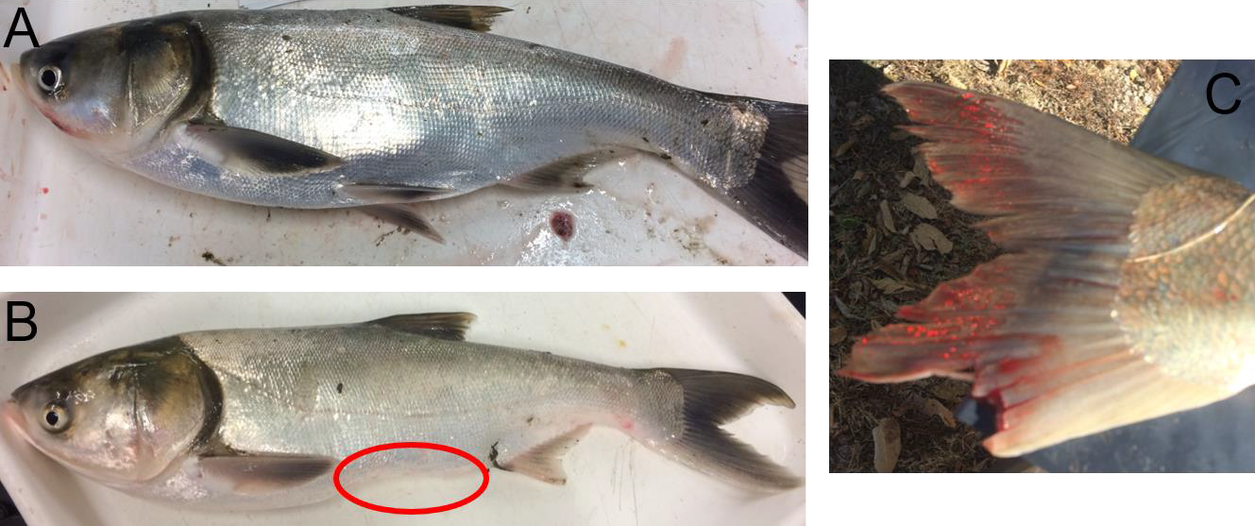

Figure S2 – Skin conditions in Silver Carp, La Grange and Starved Rock reaches, Illinois River, Illinois, USA, April-October 2018. Overall, fish had few skin aberrations and received a score of 0 for skin (A). Fish from Starved Rock were caught by commercial fishing gear (gill and trammel nets) and often had wounds resulting from this method of capture (B). Actively bleeding external wounds were considered to be a consequence of the commercial fishing gear and were not included in the HAI assessment of skin. Other skin conditions were assigned a score of 10 if they appeared to be acute aberrations, a 20 for aberrations that could potentially affect fish function, and a 30 if the aberration could impact fish survival. (C) example of a skin aberration (small wound, not capture related) receiving a score of 10. (D) example of a skin aberration (partial interruption of lateral line) receiving a score of 20. (E) example of a skin aberration (ripped mouth) receiving a score of 30.

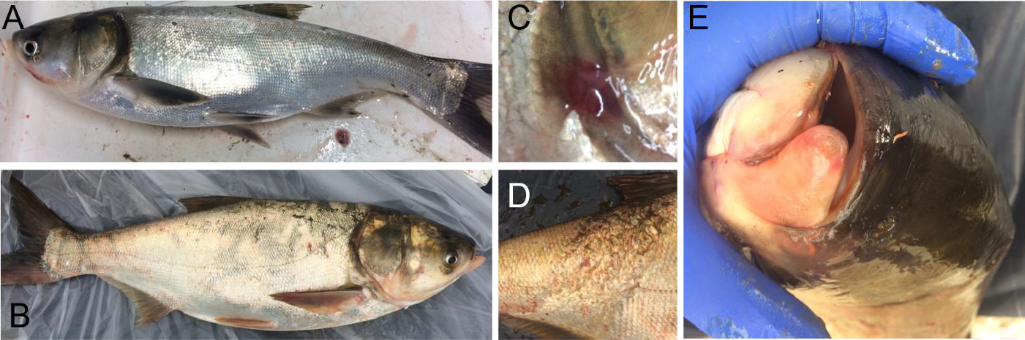

Figure S3 – Eye conditions in Silver Carp, La Grange and Starved Rock reaches, Illinois River, Illinois, USA, April-October 2019. (A) Normal eye, receiving a score of 0. (B) Opaque eye, receiving score of 30. (C) Bleeding in eye, receiving score of 30. (D) Missing eye, receiving score of 30.
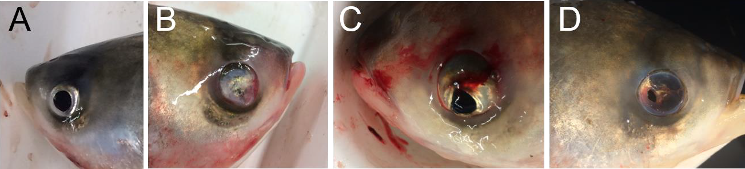

Figure S4. Gill condition in Silver Carp, La Grange and Starved Rock reaches, Illinois River, Illinois, USA, April-October 2019. No gill abnormalities were found. Both (A) and (B) below are examples of normal gills in Silver Carp, receiving a HAI score of 0.
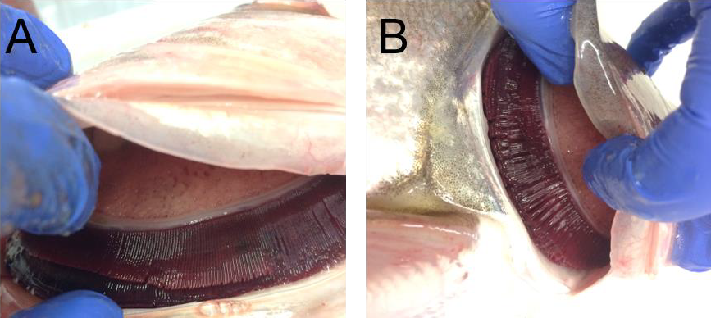

Figure S5 – Spleen condition in Silver Carp, La Grange and Starved Rock reaches, Illinois River, Illinois, USA, April-October 2019. (A) Normal spleen, receiving HAI score of 0. (B) Enlarged spleen, receiving HAI score of 30. No other spleen abnormalities were found.

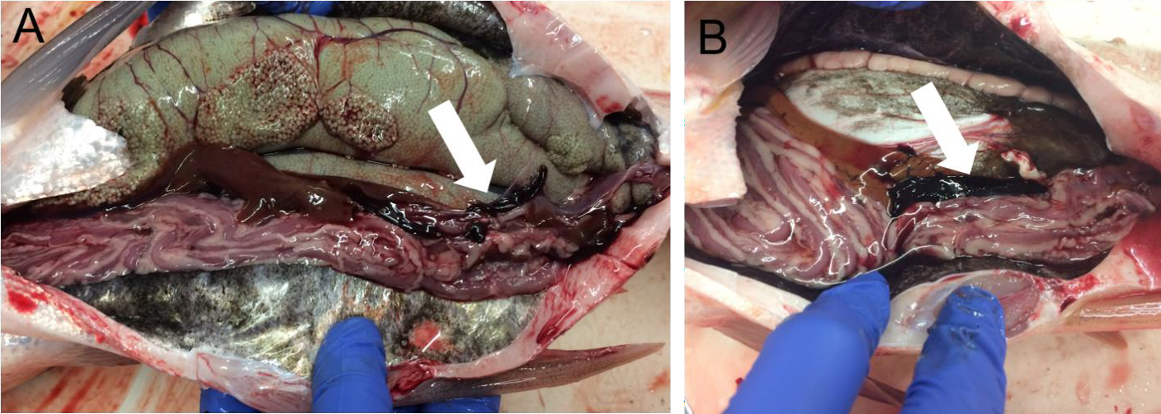

Figure S6 – Liver conditions in Silver Carp, La Grange and Starved Rock reaches, Illinois River, Illinois, USA. Liver abnormalities were common. (A) Normal liver. (B) “Fatty” liver. (C) Cysts on liver. (D) Liver with focal discoloration. (E) Liver with general discoloration. Livers B–D received HAI scores of 30, liver A received a 0.

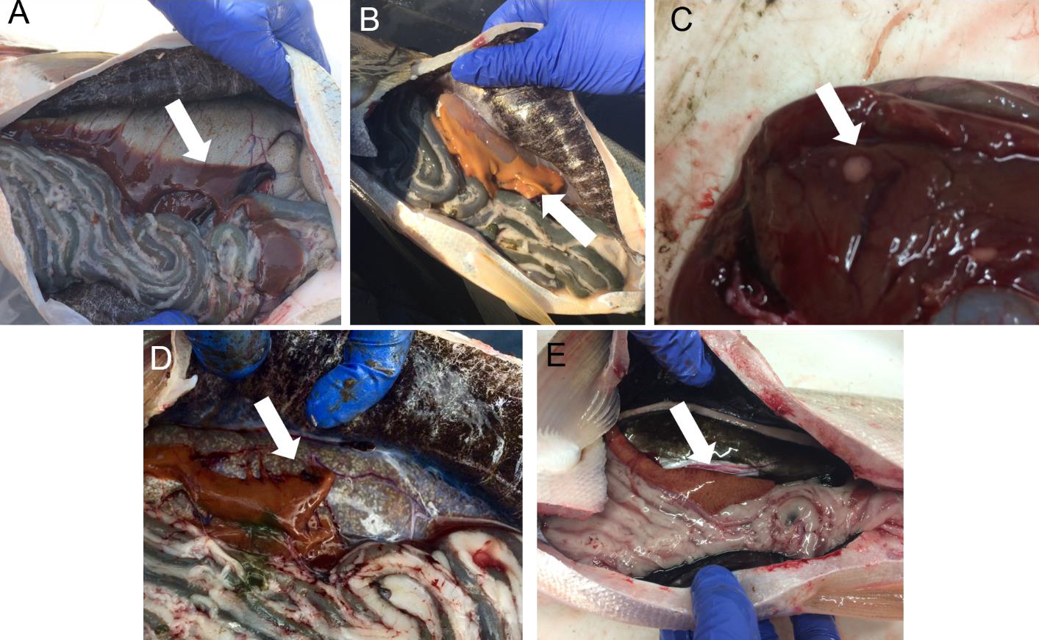

Figure S7 – Kidney conditions in Silver Carp, La Grange and Starved Rock reaches, Illinois River, Illinois, USA, April-October 2019. (A) Normal kidney, receiving HAI score of 0. (B) and (C) had white material embedded in the kidney (white arrows) and received HAI scores of 30. This condition was the only abnormal kidney condition found in Silver Carp, but it was common.

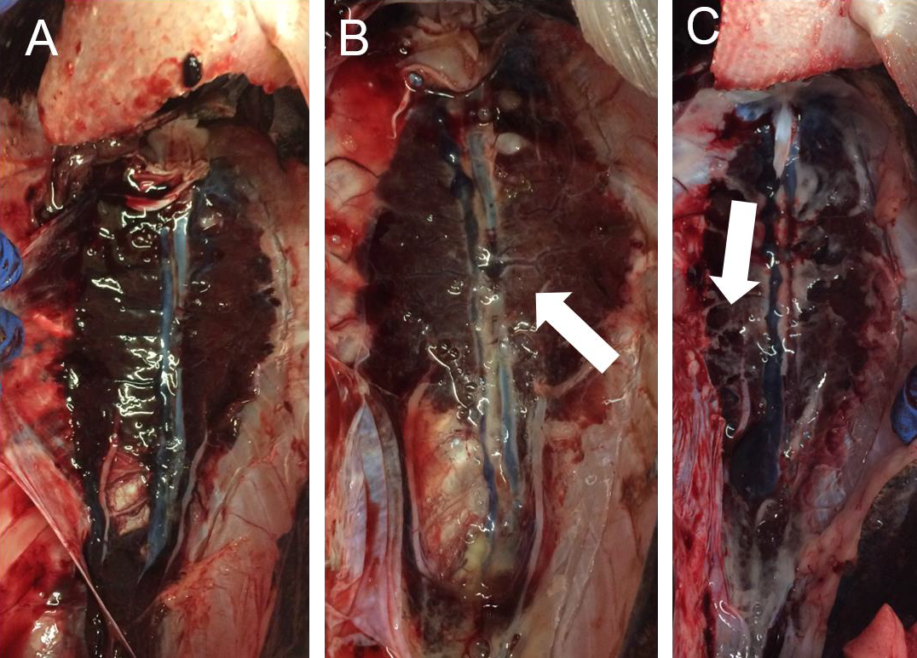

Figure S8 – Intestine conditions in Silver Carp, La Grange and Starved Rock reaches, Illinois River, Illinois, USA. (A) Normal intestine filled with phytoplankton digesta with some visceral adipose tissue, received score of 0. (B) Intestine contained very little digesta and was slightly reddened, received score of 10. (C) Intestine with moderate reddening, received score of 20. (D) Intestine with severe reddening and lack of visceral adipose tissue, received a score of 30. (E) One fish was found with a large, hard mass in its hindgut, and the intestines were also reddened. Examination of the mass revealed that the intestinal wall had hypertrophied and hardened, but there was no digesta inside of the intestine. This fish also received a HAI score of 30.
