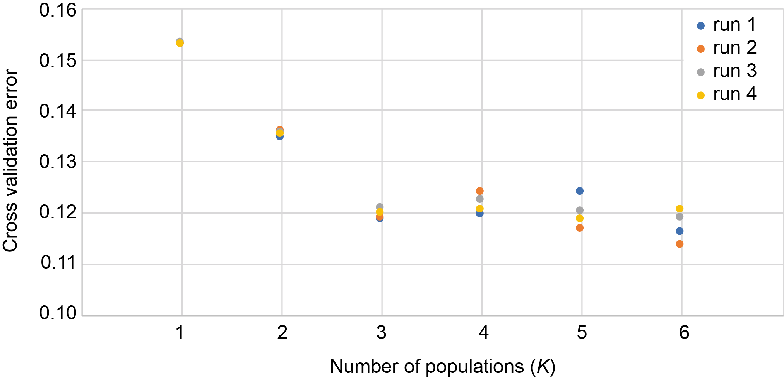
Figure S3. Replicate ADMIXTURE analyses used to determine the optimal number of populations (K). The minimum cross validation error with the least variance is K = 3.

