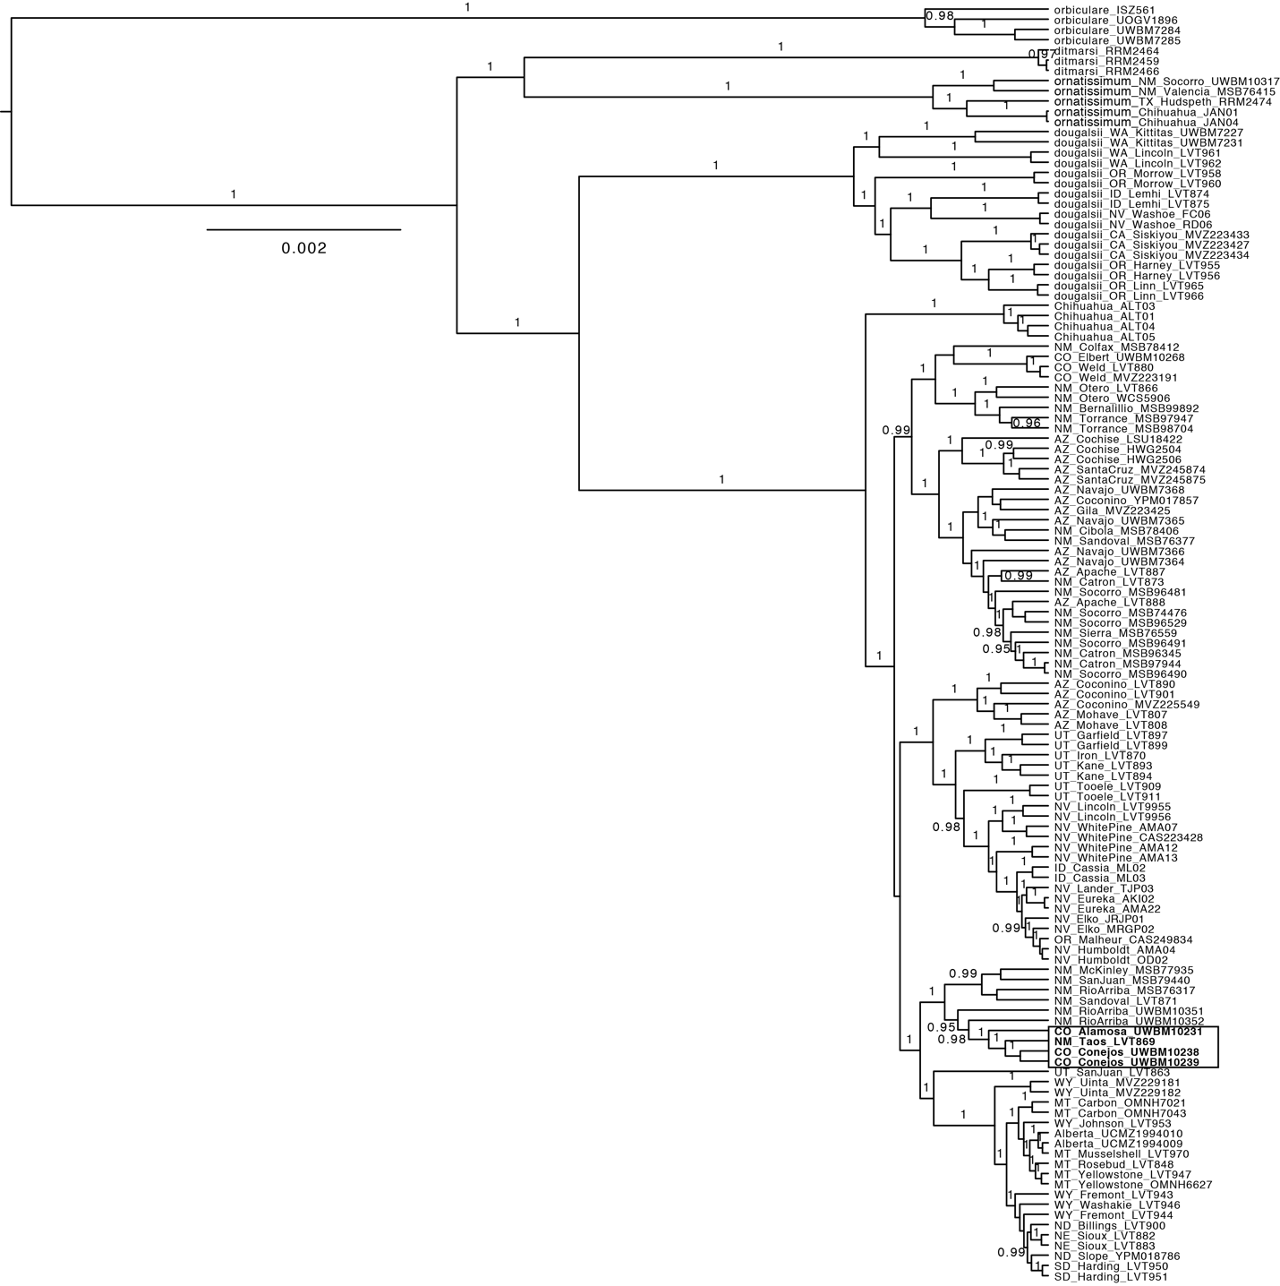

Figure S2. Bayesian phylogenetic analysis of the concatenated ddRADseq data using using BEAST. Posterior probability values ≥ 0.95 are shown on branches. Phrynosoma diminutum samples (highlighted in bold) are nested inside P. hernandesi.

