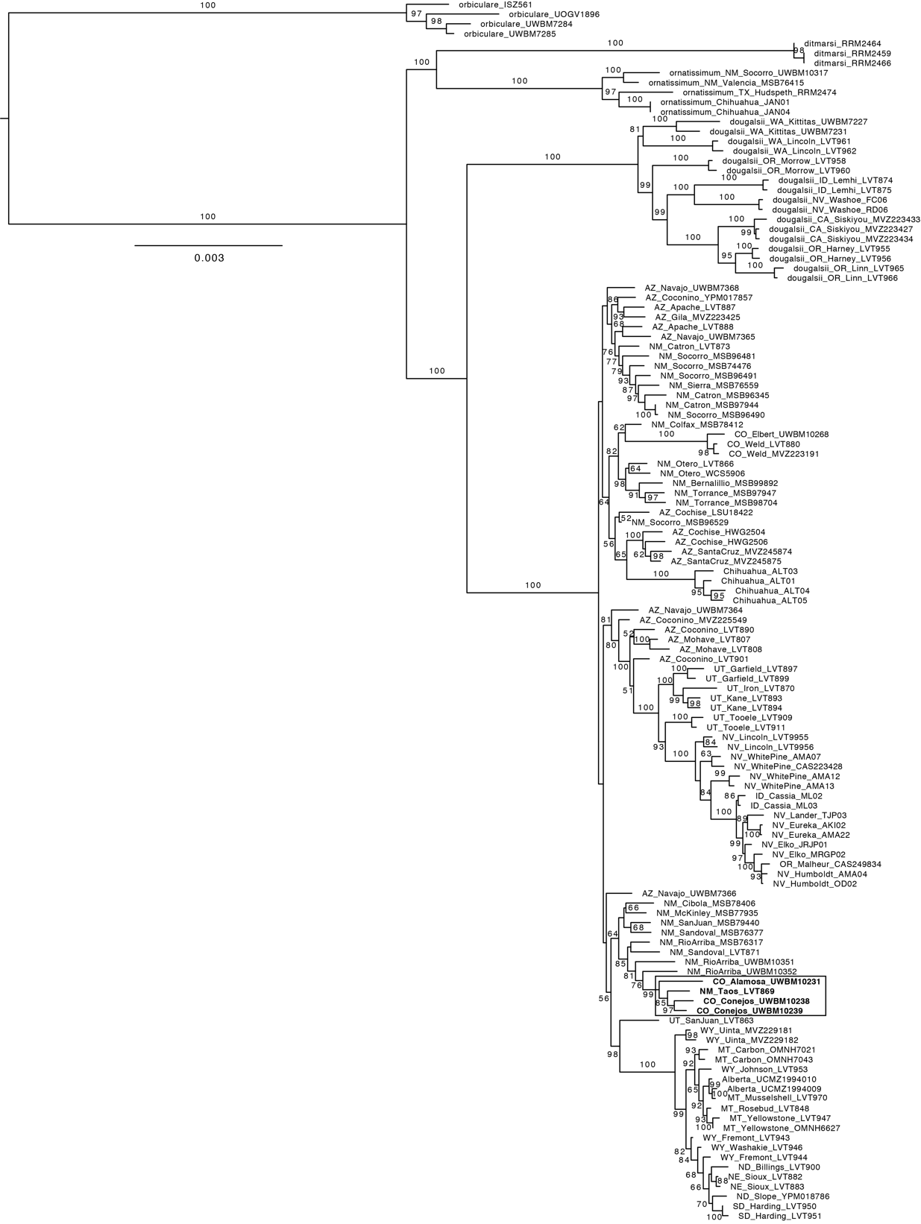

Figure S1. Maximum likelihood phylogenetic analysis of the concatenated ddRADseq data using IQ-TREE. Bootstrap values ≥ 50% are shown on branches. Phrynosoma diminutum samples (highlighted in bold) are nested inside P. hernandesi.

