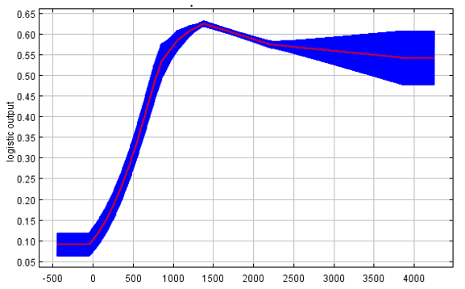

Altitude

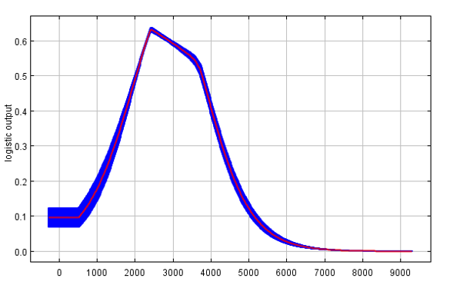

Temperature seasonality

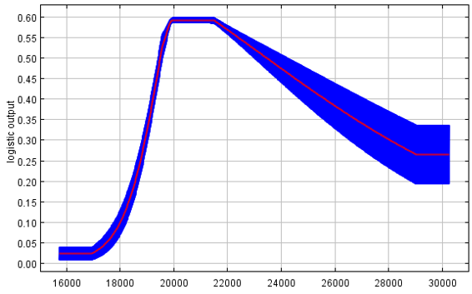

Solar irradiation

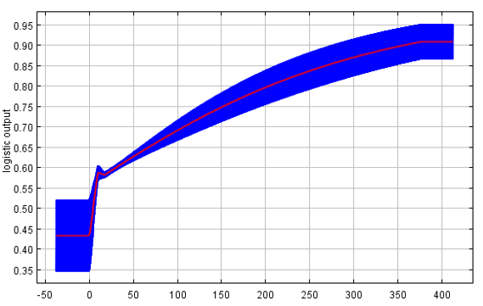

Precipitation of the driest quarter

**a**

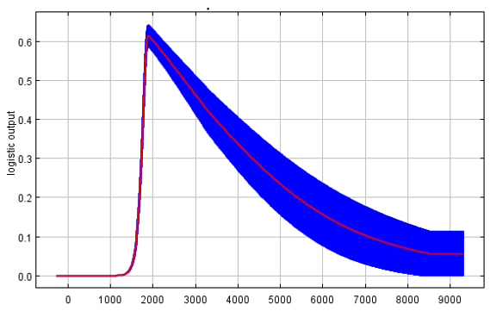

**b**

Temperature seasonality

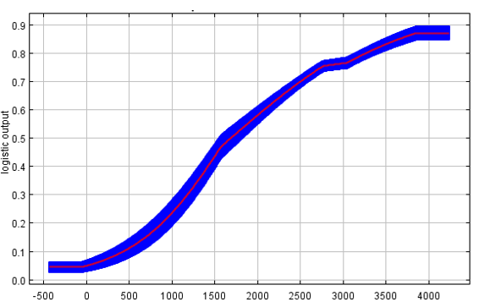

Altitude

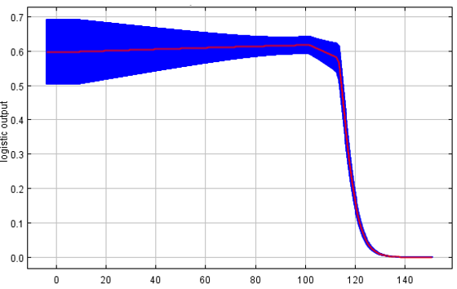

Mean diurnal range

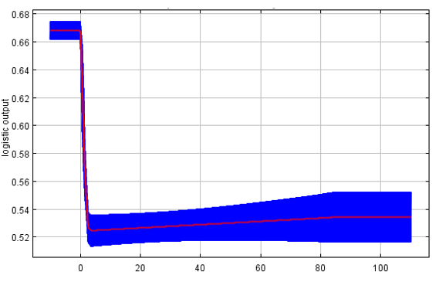

Evergreen broadleaf trees

**Suplemental Fig. 3.** Response curves of (a) Mexican Plateau, (b) Trans Mexican Volcanic Belt, (c) Sierra Madre Occidental, and (d) Sierra Madre Oriental. Showing their impact on each model prediction. The red lines in represent the mean values for 10 model replications, whereas, the blue area represents the standard deviation among the replicated runs.

**d**

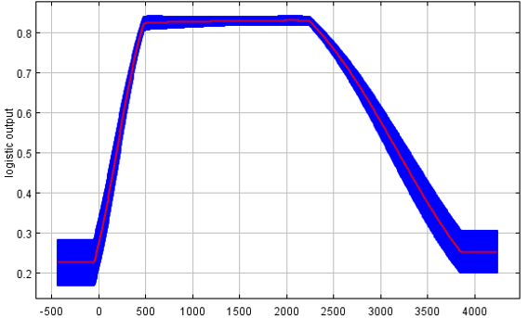

Altitude

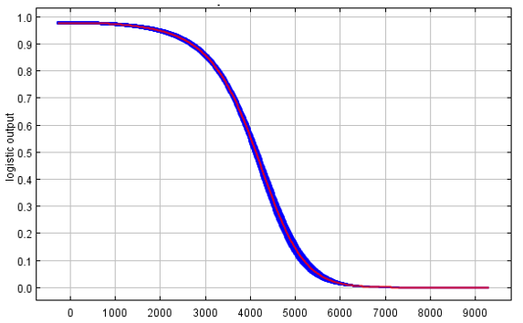

Temperature seasonality

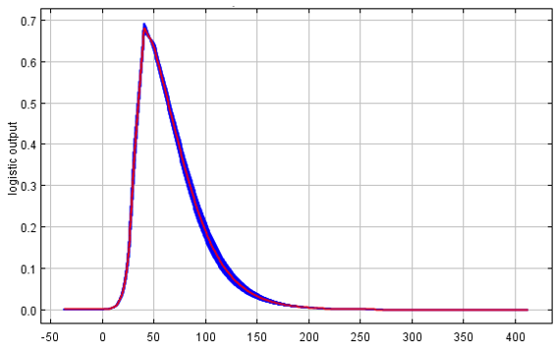

Precipitation of the driest quarter

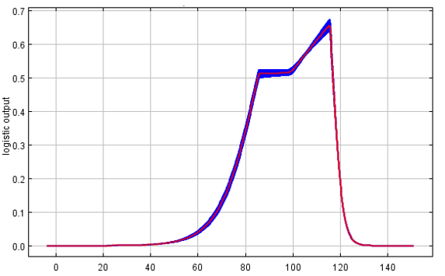

Mean diurnal range

**c**

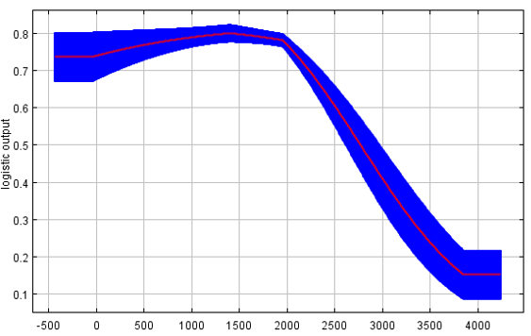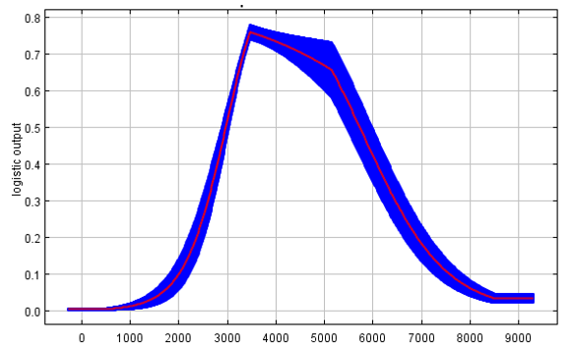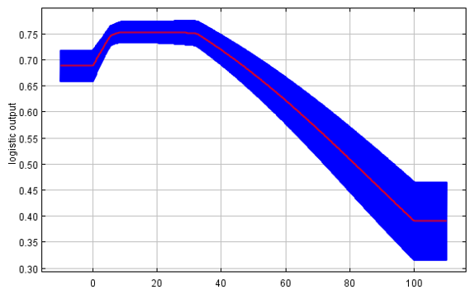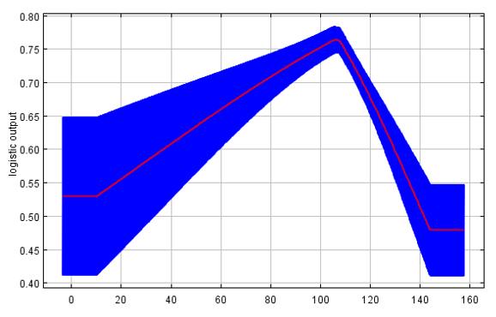

Altitude

Temperature seasonality

Precipitation seasonality

Shrubs