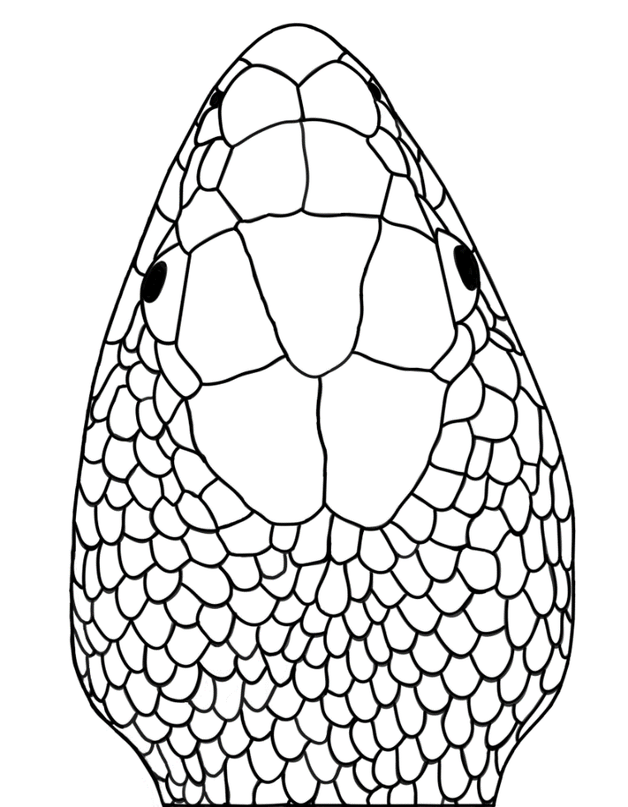

**HL**

**HW**

**JW**

**IOD**

**IND**

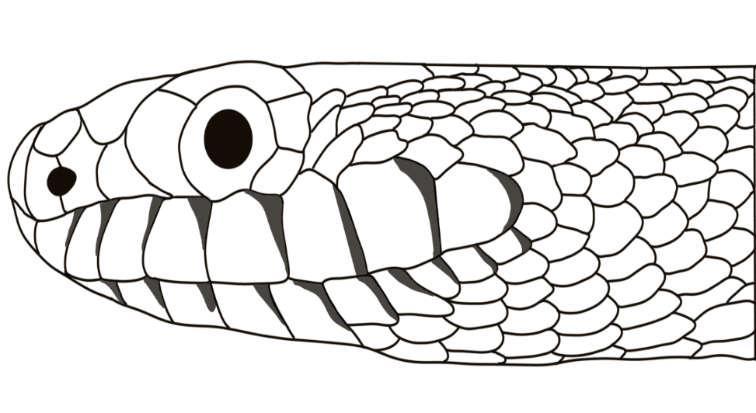

**HH**

**JL**

**ED**

**DNUL** DNUL **UL**

**DEN**

**Supplemental Fig. 1.** Linear morphometrics characters in *Pituophis deppei.* **A**, top view, Head Length (HL), Head Width (HW), Jaw Width (JW), Interocular Distance (IOD), Internasal Distance (IND). **B**, side view, Head Height (HH), Jaw Length (JL), Eye Diameter (ED), Distance Between the Nostril and the Base of the Upper Lip (DNUL), and Distance Between the Eye and the Nostril (DEN).

**A**

**B**