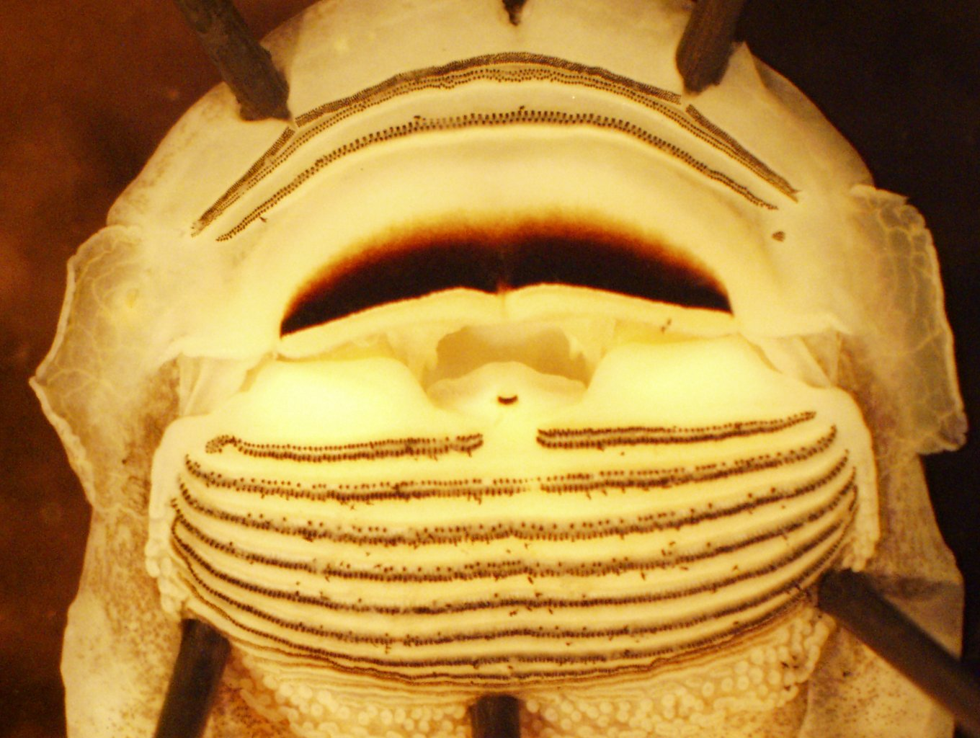
Supplemental Figure A. Pinned specimen of Ascaphus truei (specimen ID WCF07243) from Kleanza Creek, BC. The 30 tadpoles collected from BC all had a biserial P2 row, shown here, which was not observed in other A. truei tadpoles.

