Taurus of the tidepool? Inferring the function of cranial weapons in intertidal sculpins (Pisces: Cottoidea: Oligocottinae)

SUPPLEMENTARY METHODS
Summarizing evidence of sexual selection
The Sexual Selection Index (SSI) score for a given species was calculated as the sum of seven SSI factors: (1) sexual size dimorphism, (2) sexual dichromatism, (3) sexual dichromatism during the breeding season, (4) number of secondary morphological sexual characters, (5) intromittent organ, (6) nesting/territoriality, (7) other evidence of intraspecific fighting/combat. These factors were coded for each species based on an exhaustive search of published accounts and descriptions in the literature. For SSI factor 4 (number of secondary morphological sexual characters), each unique secondary morphological sexual character was given a value of “1” and the total number was summed for each species. For example, males of Artedius harringtoni have enlarged lips and an enlarged superorbital cirrus compared to females. Each of these traits then carries a value of “1” and they sum to “2.” Therefore, A. harringtoni receives a score of “2” for SSI factor 4. All remaining SSI factors are scored by presence/absence, where presence receives a value of “1” and absence receives a value of “0.” The condition of SSI factor 3 (sexual dichromatism during the breeding season) may be in addition to or in place of SSI factor 2 (sexual dichromatism). For example, males of most Artedius species develop dark coloration during the breeding season (SSI factor 3), but not all species are sexually dichromatic outside of the breeding season (SSI factor 2).
Quantifying preopercle morphology- landmark positions
There is considerable variation in the morphology of the preopercle, especially with regard to the shape and size of the preopercular spines. However, not all aspects of the shape of the preopercle are equally variable. We designed our landmark scheme to capture the shape of the preopercle and magnitude and curvature of the spines that project from it, and used the conserved number and relative positioning of the sensory pores that line the preopercle to accommodate for the variability in the number of spines.
The posterior margin of the preopercle forms a tube through which runs a branch of the cranial portion of the lateralis system (a sensory canal that runs laterally along the length of the body and across the head, for a general description of this system, see Helfman et al., 2009, for a description of this system in cottoids, see Yabe, 1985). This preopercle sensory tube has a dorsal and ventral opening as well as four additional openings in the form of pores along its posterior margin (Jackson, 2003). These openings are present in all oligocottine sculpins and, furthermore, the location of the preopercular spines with respect to these openings is consistent across all oligocottines as well. We observed that the preopercular spines project from either an elongation of the postero-ventral margin of an opening (as in the case of the ventral-most spine), or project from a space on the bone between two openings (as in the case of the remaining spines). As larvae, most sculpins develop four large, equally sized preopercular spines and this is the pleisiomorphic condition for sculpins in general and for the members of the subfamily Oligocottinae (Washington, 1986). Given the consistency in both pore count and the placement of spines with respect to the pores on the preopercle across sculpins generally, we determined that species with less than four spines had evolutionarily lost them- in essence, reducing the length of said spines to zero. We made the assumption that the location of this length-zero spine would be consistent with the location of homologous spines in sculpins generally, i.e., the spine would be located at either the distal edge of the ventral-most opening of the sensory tube for the ventral-most spine, or in between two of the four pores along the posterior edge of the preopercle for the remaining three spines. Our landmark scheme for the preopercle in oligocottine sculpins is therefore as follows: we placed landmarks on four points of the circumference of each opening, at the distal-most point on each of the four spines when present or at the locus on the preopercle where the spine would be if it were present, and at the point where the suborbital stay attaches to the anterior edge of the preopercle (Fig. S1, Table S3, see Yabe, 1985 for additional description of the morphology of the suborbital stay and its relationship to the preopercle).
The dorsal-most preopercular spine is present in all oligocottines and is highly variable in its shape and size- particularly in its length, curvature, and number of tines/spinules projecting from it. These aspects are particularly relevant for our study, but we felt that the number of spinules was so variable that it could overwhelm the ability of our landmark-based approach to meaningfully parse out the variation. We observed variation in spinule count of the dorsal-most spine not only across species, but also within several species. We therefore used the following approach to capture variation in the dorsal-most preopercular spine: we refined the definition of the landmark at the distal most point on the spine to be: “the distal most point on the spine or, when multiple spinules are present, the distal most point on the spinule that is present across all adult individuals of that species.” We additionally placed a curve of sliding semilandmarks between the preopercular pore that lies adjacent ventrally to the uppermost spine (specifically, landmark 21) and the distal-most tip of the uppermost preopercular spine (i.e., landmark 19) to capture the curvature of the spine. Each semilandmark position carries no assumption of homology, but rather, the series as a whole represents the curve of a putatively homologous structure, in our case the 3D curvature of the spine. For species with a varying number of spinules, the curve additionally captures the development of any “extra” spinules that lie distal to distal-most spinule that is present in all adult individuals of that species. This approach omits variation in the number and shape of any spinules that lie along the dorsal surface of the dorsal-most spine between the dorsal portion of its base and the distal-most tip (i.e., landmark 19). Conceivably, we could have extended the semilandmark curve to run along the full outline of the dorsal-most spine and captured this variation, as has been done to capture complex shape variation in the horn-like structures of rhinoceros beetles, which also are used as intraspecific weapons (Goczal, Rossa & Tofilski, 2019). We decided against this approach though because the morphology of the upper-most preopercular spine in oligocottines ranges from little more than a small nub (in, e.g., Clinocottus globiceps), to a long projection with multiple (3-5) large tines/spinules projecting from it (in, e.g., Chitonotus pugetensis). We felt that this level of variation exceeded the capacity of a curve to capture with enough fidelity to enable meaningful comparisons. Thus, we restricted the curve to the ventral edge of the uppermost spine and only included intraspecific variation in spinules.

Intraspecific variation- assessing landmark placement precision
We compared the Procrustes distances between the three replicates of each preopercle and between a given replicate and each replicate of the opposite preopercle for that individual using analysis of variance (ANOVA). If the average pairwise Procrustes distance between replicates of a single specimen is indistinguishable from the average pairwise Procrustes distance between the left and right side of a given individual (i.e., p > 0.05), then any asymmetry could simply be the result of landmark placement precision. Conversely, if the average pairwise Procrustes distance between replicates is significantly lower than the distance between the left and right sides of a given individual, then the observed asymmetry likely reflects biological reality.

Intraspecific variation- relative fluctuating asymmetry
Fluctuating asymmetry is normally calculated as the Procrustes distance between the asymmetric component of preopercle shape for a given individual and the average directional asymmetric shape for its species. The positive correlation between this value and the complexity of the mean shape results from the use of Procrustes distance, which is the sum of squared differences in landmark position between two specimens, and thus particularly sensitive to variation in the position and number of the distalmost landmarks. To give a sculpin example, if preopercular spine lengths universally vary by 10% among specimens of a given species, a species that has four spines projecting from its preopercle (e.g., Orthonopias triacis) will have four times as many landmarks at the tips of spines than does a species that has only one spine projecting from the preopercle (e.g., Clinocottus acuticeps), and thus four times as many highly variable landmarks contributing the square of their displacement to the overall Procrustes distance between the contralateral sides. Standardization is thus necessary to compare the levels of asymmetry between oligocottine species with highly complex preopercles (e.g. Artedius notospilotus) and those with much less complex shapes (e.g Clinocottus recalvus) (see descriptions of the preopercle for these species in Bolin, 1944).
Because we define the “relative fluctuating asymmetry (rFA)” of an individual as its fluctuating asymmetry score divided by the average Procrustes distance from the mean shape of either the left or right preopercle (whichever was greater) for that species, the denominator represents the expected variation in Procrustes distance around the mean preopercular shape for the species in question. An rFA of “1” would indicate that the Procrustes distance between the shapes of the left and right preopercles of an individual is equal to the average variation of all sampled individuals from the species mean. Put simply, an rFA of “1” indicates that there is as much variation in preopercle shape within a single individual as there is expected variation in preopercle shape for the entire species of that individual.
We extracted both the asymmetric component of shape and the directional asymmetric component of shape for a given individual from the output of the symmetry analysis performed by the “bilat.symm” function in geomorph. We calculated the mean directional asymmetric component of shape for each species, then calculated the Procrustes distance between the asymmetric component of shape for a given individual and the mean directional asymmetric shape of that individual’s species. We then obtained rFA values of each individual, averaged those values within each species to create a species-level rFA metric, and compared the species rFA to the mean preopercle shape and SSI score of each species using the phylogenetic comparative methods described in the “Macroevolutionary hypotheses” section of the main text.

SUPPLEMENTARY FIGURES
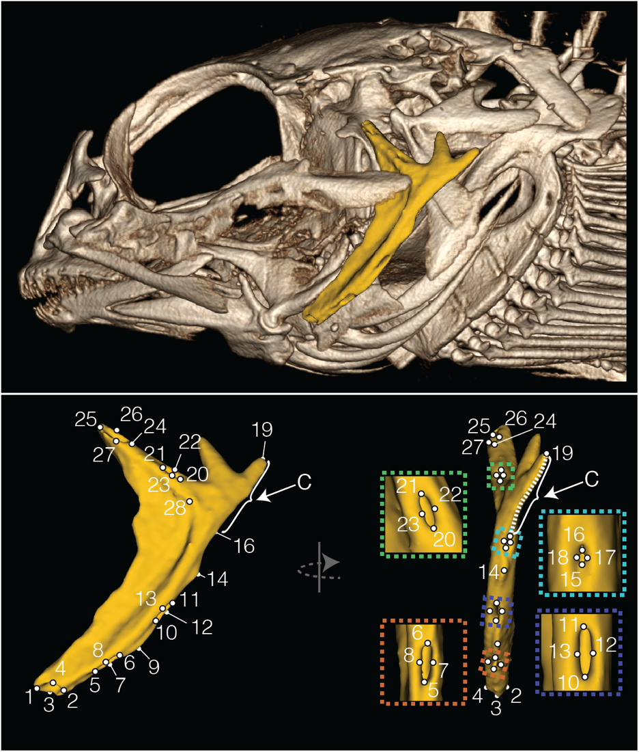
Figure S1: Upper panel: CT reconstruction of the skull of Clinocottus analis (OS Uncat, 76.55mm SL) with preopercle bone highlighted in yellow. Lower panel: lateral (left) and posterior (right) view of isolated preopercle, showing the locations of landmarks (white spheres) and semilandmarks (white, dashed line) representing the shape of the bone. Colored insets show the landmark placement in each of the four pores of the lateralis system. The curve captured by the series of semilandmarks is indicated with an arrow and the letter “C.”

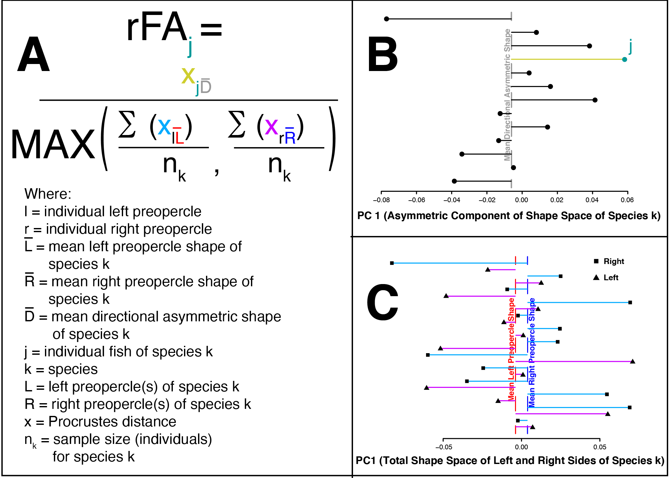
Figure S2: Calculating relative fluctuating asymmetry (rFA). Panel A shows the formula for calculating rFA for an individual specimen, j. The rFA of j is equivalent to the fluctuating asymmetry (FA) of j divided by either the average Procrustes distance of the left preopercles from the mean shape of the left preopercles or the average Procrustes distance of the right preopercles from the mean shape of the right preopercles, whichever is greater. Panel B is a graphical depiction of the numerator of the rFA equation in panel A (i.e., it depicts the FA of j), which is equivalent to the Procrustes distance between the asymmetric component of shape of specimen j and the mean directional asymmetric shape of all specimens of the same species as j. The shape space of the asymmetric component of shape is represented with the PC1 values of each specimen of the species to which j belongs, from a PCA of the asymmetric component of shape for all specimens of that species. The PC1 values of each specimen are represented by filled circles. The mean directional asymmetric shape of the species to which j belongs is depicted with a vertical dashed grey line. The Procrustes distance between the asymmetric shape of each individual and the mean directional asymmetric shape of the species is represented with a horizontal line connecting the dot to the dashed grey line. The asymmetric component of shape of specimen j is depicted with a green dot. The Procrustes distance between the asymmetric component of shape of specimen j and the mean directional asymmetric shape of the species to which j belongs is depicted with a light green horizontal line. Only the Procrustes distance represented by the green line is used to calculate the numerator for specimen j. Panel C is a graphical depiction of the denominator of the rFA equation. The shape space of all preopercles of all individuals of the same species as specimen j is represented by the PC1 values of each specimen of the species to which j belongs, from a PCA of the shapes of left and reflected right preopercles from all specimens of the same species as j. The PC1 values of the left preopercles are represented with triangles and the PC1 values of the right preopercles are represented with squares. The mean left preopercle shape is represented with a vertical dashed red line. The mean right preopercle shape is represented with a vertical dashed blue line. The Procrustes distance between each left preopercle and the mean left preopercle shape is represented with a horizontal pink line. The Procrustes distance between each right preopercle and the mean right preopercle shape is represented with a horizontal light blue line. The average Procrustes distance of the left preopercles to the mean left preopercle shape is calculated by summing all of the distances represented by pink lines and dividing that number by the total number of left preopercles. The average Procrustes distance of the right preopercles to the mean right preopercle shape is calculated by summing all of the distances represented by light blue lines and dividing that number by the total number of right preopercles. The greater of the two becomes the denominator in the rFA equation for specimen j. Note that the denominator is constant for all individuals of the same species as j, and represents the expected variation in shape around the mean in terms of Procrustes distance.

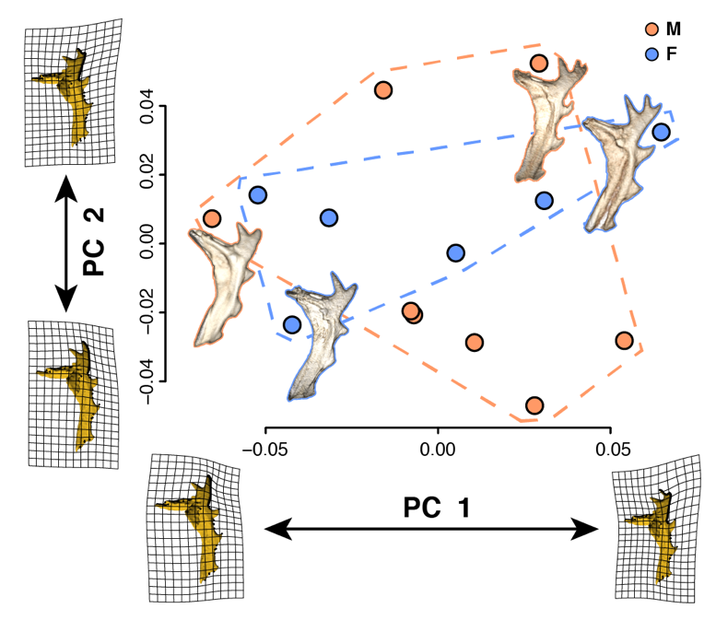
Figure S3: Lack of sexual dimorphism in Orthonopias triacis. Each dot represents the symmetric component of the shape of the left and right preopercle for an individual fish, which is equivalent to the average shape of the left and reflected right side. The preopercles of male individuals are circled in orange, the preopercles of female individuals are circled in blue. The shape change captured by PC1 and PC2 is represented by transformation of a model of the average shape of the preopercle in O. triacis, with a TPS transformation grid overlaid. The extreme values of the two axes are illustrated with a CT reconstruction of the right preopercle of a male and female.

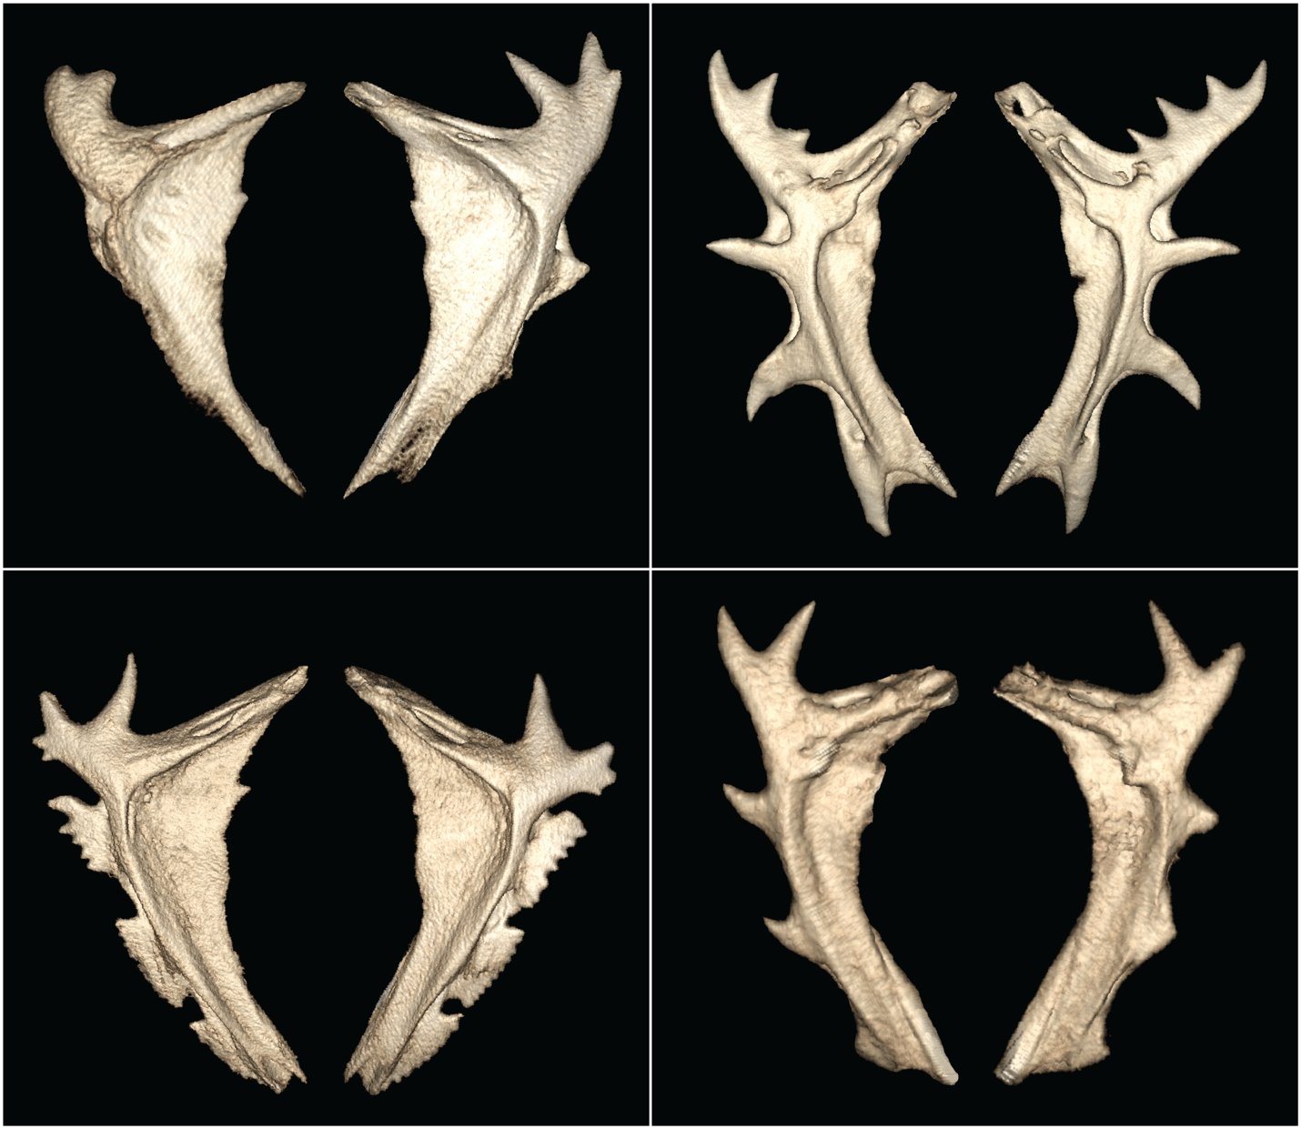
Figure S4: Examples of left-right asymmetry of preopercle shape in individual specimens of oligocottine taxa. Clockwise, from top-left: Artedius fenestralis (OS uncat, 70.84mm SL), Chitonotus pugetensis (OS 6542, 95.49mm SL), Orthonopias triacis (SIO 51-249, 51.50mm SL), and Artedius notospilotus (SIO 73-101, 120.64mm SL).

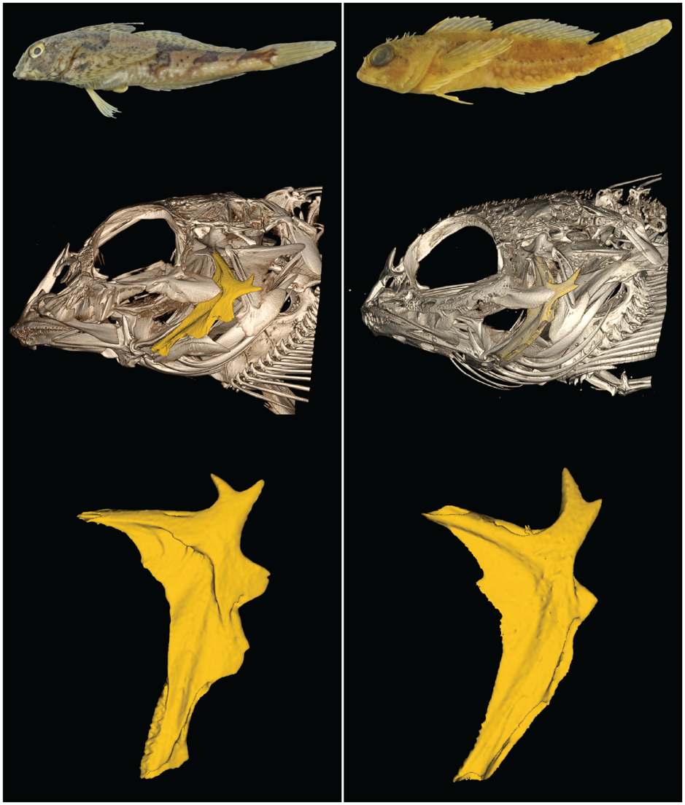
Figure S5: External morphology, skull morphology (preopercle bone highlighted in yellow), and preopercle morphology of specimens representing Leiocottus hirundo (SIO 59-307 139mm SL; left panel) and Artedius harringtoni (OS 7471 39mm SL; right panel). These species have very similar morphology of the uppermost preopercular spine but disparate SSI scores.

SUPPLEMENTARY TABLE CAPTIONS

Table S1: Species, museum ID, length, sex, morphosource ID, scan parameters.

Table S2: Sample size, size range, and summary of results for all species included in this study. Bolin (1944) examined specimens from all 16 species in Oligocottinae as well as the outgroup taxon Chitonotus pugetensis (i.e., all species included in the current manuscript). Bolin (1944) noted sexual size dimorphism, sexual dichromatism, and secondary sexual morphological characters (i.e., sexual selection index factors 1,2,& 4) for some species, but not for others even though he examined all species. For these characters then, 0’s likely indicate true absence. For SSI factor 7 (nesting/territoriality), 0’s with a reference indicate species in which parental care is known to not occur. For all other 0’s, we found no evidence of the character having been observed despite exhaustive study of the literature, but these characters may simply not yet have been discovered or described for those species. This is especially true for behavioral characters (i.e., SSI factors 6 & 7).
.
Table S3: Anatomical description of landmark and semilandmark placement.

Supplemental References
Bolin RL. 1944. A review of the marine cottid fishes of California. Stanford Ichthyological Bulletin 3:1–135.
Goczal J, Rossa R, Tofilski A. 2019. Intersexual and intrasexual patterns of horn size and shape variation in the European rhinoceros beetle: quantifying the shape of weapons. Biological Journal of the Linnean Society 127:34–43.
Helfman G, Collette BB, Facey DE, Bowen BW. 2009. The diversity of fishes: biology, evolution, and ecology. John Wiley & Sons.
Jackson KL. 2003. Contributions to the systematics of Cottoid fishes (Teleostei: Scorpaeniformes).
Washington BB. 1986. Systematic relationship and ontogeny of the sculpins artedius, clinocottus, and oligocottus (Cottidae: Scorpaeniformes). Proceedings of the California Academy of Sciences 44:157–224.
Yabe M. 1985. Comparative osteology and myology of the superfamily Cottoidea (Pisces: Scorpaeniformes), and its phylogenetic classification. Memoirs of the Faculty of Fisheries-Hokkaido University (Japan) 32:1–130.

SUPPLEMENTARY MATERIALS CAPTIONS
This supplementary dataset consists of an annotated R script, 3D landmark data for the left and right preopercle bones of 221 specimens representing each of the 16 species in the sculpin fish subfamily Oligocottinae plus the outgroup taxon Chitonotus pugetensis, and additional data files relating to the attributes of the specimens (e.g., standard length) and the species which they represent (e.g., maximum known size). The files contain all of the necessary information to peform all analyses conducted in "Taurus of the tidepool? Inferring the function of cranial weapons in intertidal sculpins (Pisces: Cottoidea: Oligocottinae)", and the R script performs all said analyses with annotations to guide the reader through each.

Supplementary Materials 1.1: Annotated R script for performing all analyses conducted in the manuscript. The script is divided into sections corresponding to the sections of the methods section in the manuscript. To run the analyses, create a folder in a convenient location (e.g., the desktop of your computer) titled, “Cranial_Weapons_R”, then move all supplementary materials (1.1 - 1.9) into this folder. You may then follow the instructions of the script to perform all analyses and visualize the results of our study.

Supplementary Materials 1.2: Annotated R script of custom functions for performing some of the analyses in this study.

Supplementary Materials 1.3: Landmark coordinate data for the three replicates of the left and right preopercle of all specimens analyzed in this study. The data are in .TPS format.

Supplementary Materials 1.4: Specimen information for each replicate of each side of each specimen used in this study. The data are in comma seperated values (.CSV) format.

Supplementary Materials 1.5: Specimen information for each indivdiual specimen (i.e., replicates of left and right sides all together) used in this study. The data are in .CSV format.

Supplementary Materials 1.6: A 3D model of the left preopercle of a specimen of Artedius lateralis (OS 3178, 66.48mm SL) used in this study. The model is in Polygon File Format (.PLY).

Supplementary Materials 1.7: An ultrametric phylogenetic hypothesis of sculpins first published in Buser et al. (2017; reference number 48). The data are in NEXUS format.

Supplementary Materials 1.8: Information for each species of sculpin used in this study. The data are in .CSV format.

Supplementary Materials 1.9: A 3D model of the left preopercle of a specimen of Clinocottus analis (OS 6710, 69.20mm SL) used in this study. The model is in Polygon File Format (.PLY).

