Supplementary materials for Hydroperiod impacts on the fall-breeding ambystomatid salamanders Ambystoma annulatum and Ambystoma opacum
Authors: Thomas L. Anderson¹, Mariah N. Mack, Jessica L. Sandoval
¹Department of Biological Sciences, Southern Illinois University Edwardsville, Box 1651, Edwardsville, IL 62026, 618-650-3907, thander@siue.edu

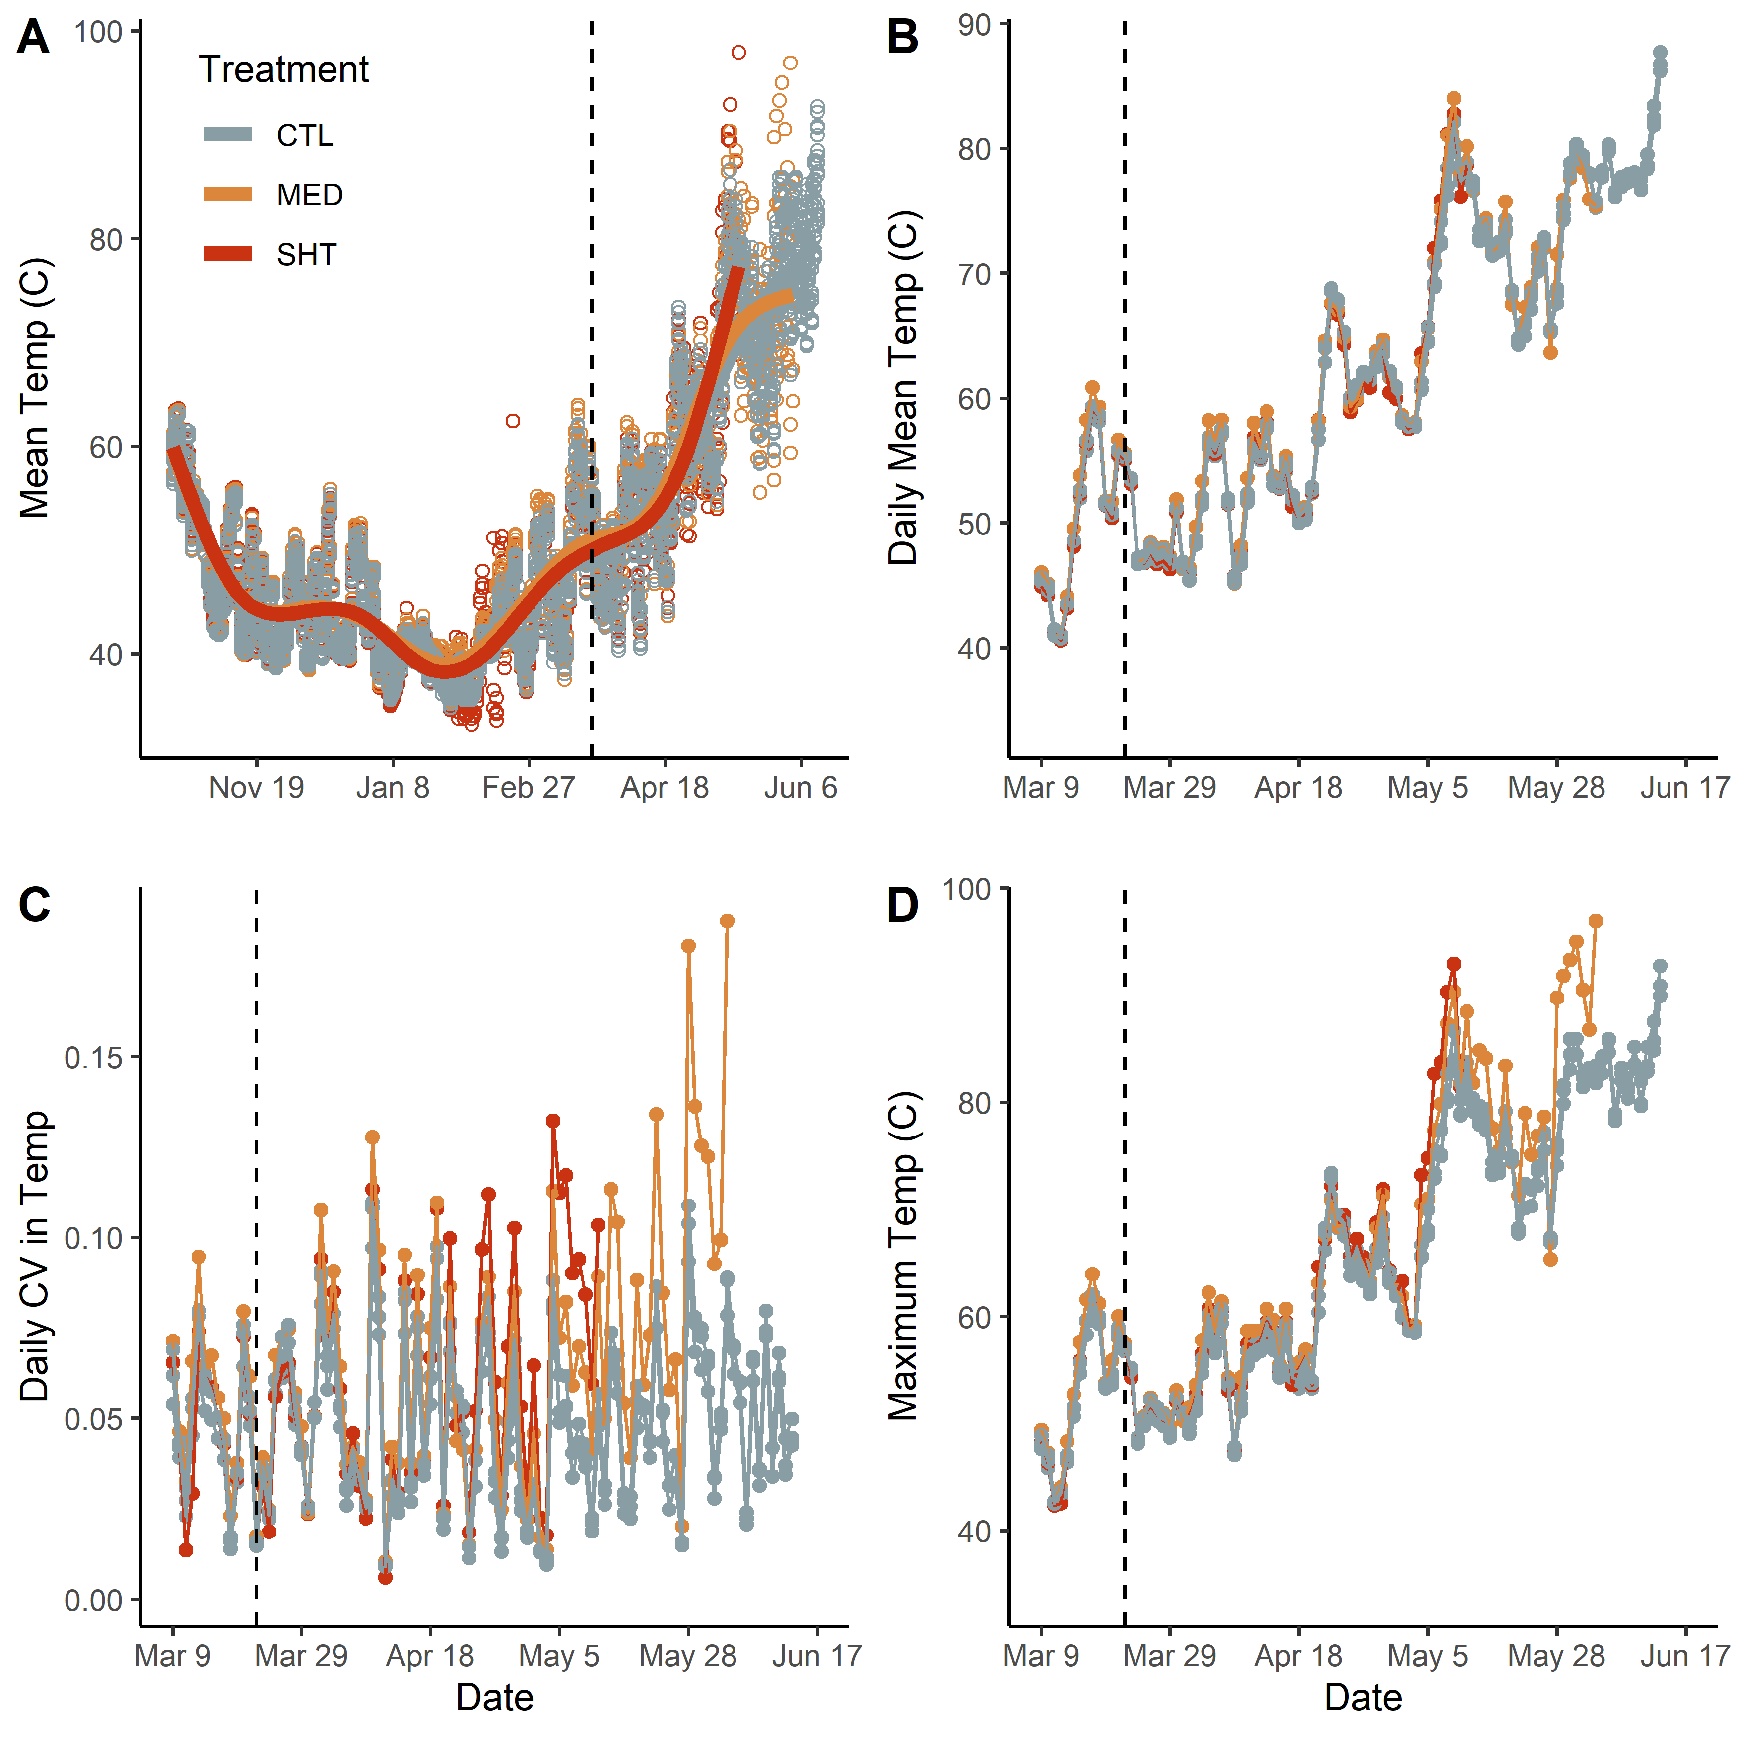
Figure S1: Temperature profiles of each hydroperiod treatment. A shows all data points across the entire experiment, taken at 4-hour intervals. B shows the daily average temperature across the period when the drying treatments were implemented. C shows the daily coefficient of variation in temperature when the drying treatments were implemented. D shows the maximum temperature in each on each day for each treatment.

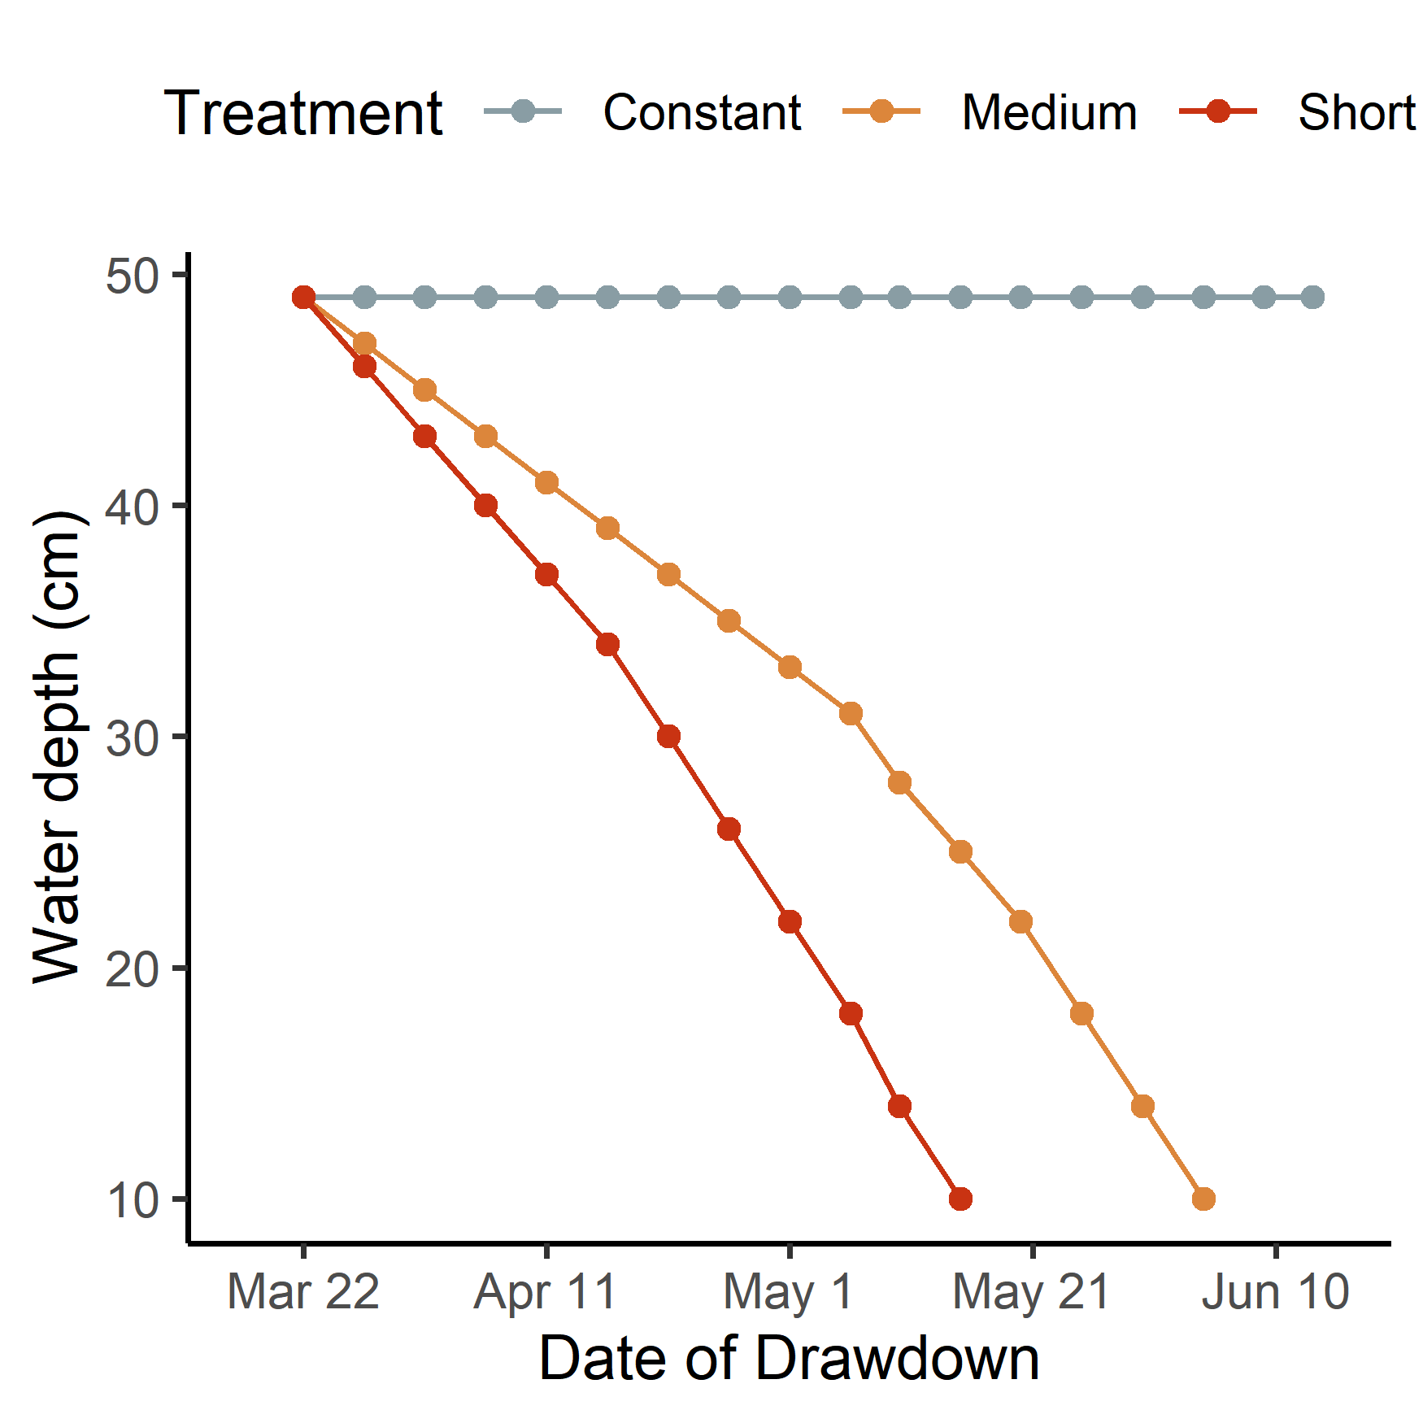
Figure S2: Drying curve used for each hydroperiod treatment. The y-axis shows the water depth (in cm) in each tank, and the axis the date that the water was changed to that level. Tanks were maintained for 1 day at the end of being “dry” and then searched for remaining salamanders. The x-axis dates correspond to following experimental day: Mar 22 = 155; Apr 11 = 175; May 1 = 195; May 21 = 215; Jun 10 = 235.

